Referral Radar
Case managers at WorkSafeBC are tasked with managing large volumes of often under tight timelines and with evolving clinical information. Despite their expertise and dedication, the sheer volume and variability of documentation—such as medical notes, claim histories, and assessments—can make it difficult to consistently identify early indicators of a beneficial referral. As a result, opportunities for timely referral to relevant care may be missed or delayed, leading to delayed interventions, prolonged recovery, and increased risk of long-term disability.
Problem Justification: The Need for Referral Radar in Chronic Pain Management
Chronic pain is a pervasive and costly health issue in Canada, affecting approximately one in four Canadians and representing a leading cause of long-term disability. Research from the Canadian Pain Task Force and the Institute for Work & Health has shown that persistent pain following injury—particularly in workplace settings—is strongly associated with delayed recovery, reduced return-to-work rates, and significantly increased healthcare and wage replacement costs. Workers experiencing chronic pain are twice as likely to remain off work 18 months post-injury and incur nearly 50% more in lost earnings and over 125% more in healthcare expenditures compared to those without persistent pain.
Despite its prevalence and impact, chronic pain is often under-recognized in the early stages of recovery, especially when psychosocial risk factors—such as fear-avoidance, catastrophizing, or mental health concerns—are not systematically identified. This gap in early detection contributes to the progression from acute to chronic pain, leading to prolonged disability and increased strain on workers’ compensation systems. Provincial compensation boards across Canada have acknowledged the need for early intervention and functional restoration programs, yet implementation remains inconsistent.
Referral Radar is designed to address this critical gap by providing a structured, evidence-informed tool that monitors recovery milestones and flags individuals at risk of developing chronic pain. By integrating clinical indicators, psychosocial risk factors, and functional data from claim files, Referral Radar enables timely, targeted interventions that can prevent chronicity, support return-to-work planning, and reduce the long-term burden on compensation systems. Its use represents a proactive, data-driven approach to improving outcomes for injured workers and enhancing the efficiency of rehabilitation pathways.
Narrowing Scope

Why Focus on Chronic Pain and the PMMP Program?
- High Impact, High Complexity
Chronic pain is one of the most complex and costly conditions managed within WorkSafeBC’s healthcare programs. It often involves long claim durations, multiple providers, and significant psychosocial factors. Early identification and intervention are critical to improving outcomes and reducing long-term disability.
- Rich Data Environment
PMMP is a well-established back-end program and generates a large volume of structured and unstructured data—clinical notes, assessments, referrals, and progress reports. This makes it an ideal environment for training and testing AI models that rely on natural language processing and pattern recognition.
- Clear Early Indicators
There are known early markers of chronic pain risk—such as repeated mentions of pain in clinical notes, delayed recovery trajectories, or psychosocial red flags—that can be detected through AI. Referral Radar can be trained to recognize these signals and prompt earlier, more consistent referrals to PMMP.
- Tangible Outcomes
By focusing on chronic pain, the Referral Radar pilot can demonstrate measurable improvements in: Time to referral, Appropriateness of referrals, Claim duration, Worker satisfaction, Cost savings, Provider Effectiveness & Experience
- Strategic Alignment
This use case directly supports WorkSafeBC goals to: Improve processes and stakeholder experience, Strengthen success metrics for healthcare programs, Reduce long-term disability and improve return-to-work outcomes
- Scalability
Overall, the use of chronic pain and PMMP serves as a digestible data point to demonstrate effectiveness of use of AI in claims processes that points to consideration of expanded use of this technology.
Refined Problem Statement
Case managers at WorkSafeBC manage high volumes of claims under significant time pressure, making it difficult to consistently detect early indicators of chronic pain. This can result in delayed interventions, higher health care costs, and increased risk of long-term disability. As of now the cost of chronic pain related conditions for DURATION is COST. Research indicates that early intervention results in PERCENT AMOUNT reduction in healthcare costs
Referral Radar Logic Model: Chronic Pain Detection & Referral
1. Inputs
- Claim file data (medical reports, clinical notes, call logs, emails)
- NLP and AI tools (for text analysis, sentiment detection, pattern recognition)
- Historical data on chronic pain claims and outcomes
- Referral criteria for the Pain Management Program (PMMP)
- Case manager workflows and decision points

2. Activities
- Use AI to scan incoming claim documents for early indicators of chronic pain (e.g., persistent pain language, psychosocial flags, strained employer relations)
- Apply predictive models to assess chronic pain risk within the first 16 weeks
- Generate real-time alerts or referral prompts for case managers
- Provide contextual explanations and supporting evidence for each alert
- Track referral decisions and outcomes for continuous learning

3. Outputs
- Risk scores or flags for potential chronic pain cases
- Suggested referral pathways (e.g., PMMP, early intervention, mental health support)
- Dashboards for case managers and leadership showing referral trends
- Feedback loops to refine AI models based on outcomes

4. Short-Term Outcomes
- Earlier identification of high-risk cases
- More consistent and appropriate referrals to PMMP
- Reduced decision-making burden on case managers
- Improved coordination between case managers, providers, and employers

5. Long-Term Impact
- Reduced incidence of long-term disability due to chronic pain
- Improved recovery outcomes and worker satisfaction
- Lower healthcare and claim costs
- Stronger, data-informed referral processes across WorkSafeBC
- Possibility to scale to a greater range of programs

Referral Radar Sample Flow:

  - Initial program- Customized recovery and return to work program (12 weeks duration)
  - Check in points- 4, 8, 12, 16 weeks(?)
    - At each check in point Radar would identify relative risk for chronic pain utilizing key points from information it has been fed such as
        - Clinical Documentation & Medical Reports
          - Clinical key words
          - Assessment results(specific pain/kineseophobia assessments)
          - Persistent or worsening pain beyond expected healing timelines
          - Early prescription of opioids or neuropathic medications
          - Key diagnosis clinically indicated and related to chronic
          - Psychosocial risk factors noted (e.g., anxiety, depression, fear-avoidance)
        - Worker–Case Manager Interactions
          - Repeated expressions of unresolved or worsening pain
          - Language indicating catastrophizing (e.g., “I’ll never get better”)
          - Requests for second opinions or additional support
          - Mentions of sleep issues, fatigue, or emotional distress
          - Frustration or hopelessness about recovery
          - Descriptions of social withdrawal or inability to function normally
        - Claim File Patterns & Administrative Data
          - Multiple extensions of time-loss benefits
          - Frequent medical visits without clear progress
          - Delayed or absent return-to-work planning
          - Multiple referrals without resolution
          - Conflicting diagnoses or treatment plans
          - Early signs of disengagement from the claim process
          - Language and sentiment analysis
        - Language & Sentiment Analysis
        - Worker–Employer & Employer–WorkSafeBC Interactions
          - Reports of strained communication between worker and employer
          - Documentation of conflict, mistrust, or lack of support from the employer
          - Employer expressing doubt about the legitimacy of the injury or pain
          - Lack of modified duties or accommodation offers
          - Delays or resistance in return-to-work coordination
  - Each check result in a relative risk rate with CO recommendation

Example: Recommendation Matrix by Timeline
Timepoint | Risk Level | Indicators | Referral Radar Recommendation | Rationale
4 Weeks | Low | Mild pain, improving function | No action or light monitoring | Early stage; normal healing expected
 | Moderate | Pain >3/10, mild fear-avoidance | Notify provider to monitor; suggest early screening | Early intervention can prevent chronicity
 | High | Severe pain, missed work, yellow flags | Recommend early multidisciplinary assessment | High risk of chronic pain development
8 Weeks | Low | Functional gains, engaged in rehab | Continue current care; optional check-in | Recovery on track
 | Moderate | Plateaued recovery, mild distress | Recommend reassessment and possible care plan adjustment | Risk of delayed recovery
 | High | Persistent pain, psychosocial distress | Refer to pain program or psychology | Chronic pain risk increasing
12 Weeks | Low | Near baseline function, low distress | Prepare for discharge or tapering care | Recovery likely complete
 | Moderate | Fluctuating symptoms, work avoidance | Recommend functional restoration or coaching | Chronicity risk present
 | High | No improvement, high disability | Flag for chronic pain diagnosis; initiate long-term plan | Chronic pain likely
16 Weeks | Low | Stable function, self-managing | No action; consider discharge | Recovery sustained
 | Moderate | Inconsistent function, flare-ups | Recommend booster sessions or vocational support | Risk of relapse or long-term disability
 | High | Diagnosed chronic pain, no RTW | Refer to chronic pain team; long-term support planning | Chronic pain confirmed

Additional Information:

Consideration Early Indicators of Chronic Pain (Data Points)
1. Clinical Documentation & Medical Reports
• Persistent or worsening pain beyond expected healing timelines
• Descriptions of pain using terms like “burning,” “throbbing,” “shooting”
• High or increasing pain intensity scores
• Pain in multiple or diffuse body areas
• Lack of improvement despite treatment
• Early prescription of opioids or neuropathic medications
• Diagnoses of fibromyalgia, chronic strain, or myofascial pain
• Psychosocial risk factors noted (e.g., anxiety, depression, fear-avoidance)
2. Worker–Case Manager Interactions
• Repeated expressions of unresolved or worsening pain
• Language indicating catastrophizing (e.g., “I’ll never get better”)
• Requests for second opinions or additional support
• Mentions of sleep issues, fatigue, or emotional distress
• Frustration or hopelessness about recovery
• Descriptions of social withdrawal or inability to function normally
3. Claim File Patterns & Administrative Data
• Multiple extensions of time-loss benefits
• Frequent medical visits without clear progress
• Delayed or absent return-to-work planning
• Multiple referrals without resolution
• Conflicting diagnoses or treatment plans
• Early signs of disengagement from the claim process
4. Language & Sentiment Analysis
• Increasing use of negative emotional tone in communication
• Repetitive pain-related language across documents
• Low-confidence or passive language (e.g., “I don’t think I can”)
• Withdrawn or resigned tone in emails or call notes
5. Worker–Employer & Employer–WorkSafeBC Interactions
• Reports of strained communication between worker and employer
• Documentation of conflict, mistrust, or lack of support from the employer
• Employer expressing doubt about the legitimacy of the injury or pain
• Lack of modified duties or accommodation offers
• Delays or resistance in return-to-work coordination
• Employer reports of performance issues or disciplinary action post-injury
• Case manager notes indicating difficulty engaging the employer in recovery planning

Product & Features
Product
Referral Radar is your intelligent assistant — scanning claim data for hidden mental health signals and helping case managers make faster, more confident recommendations
Features
- Claims AI agent (user facing)
- Extractor for Claim Artifacts - Agentic AI can extract relevant unstructured data from medical notes, history, and case narratives.
- Extractor for policies/guidelines - Agentic AI can extract relevant unstructured data from mental health policies and regulatory guidelines
- Reasoner - Agentic AI accurately parses and summarizes claim context, distinguishing between overlapping services and identifying key factors (e.g., chronicity, comorbidities, prior to program use) - include external policies and guidelines
- Chat agent - that enables case managers to chat with an agent for real-time clarification on complex claim details
- Recommender - Agent AI consistently recommends healthcare programs aligned with claim owner decisions or approved guidelines (e.g., 80%+ agreement rate with SME-reviewed cases).
- Seamless integration with claim systems (CMS or equivalents) without disrupting current workflows.
- MCP server (technical advancement)
  - Common super-power for future agents

Problem Statement
Claim owners face two key barriers to making timely, appropriate mental health (MH) referrals:
Lack of decision support: Critical context—such as red flags, comorbidities, and prior history—is buried in unstructured data, making it difficult to assess referral needs quickly. The goal to identify mental health referrals earlier on to guide early intervention.

Unclear program fit: Even when MH needs are identified, overlapping services and inconsistent guidance make it hard to match claims to the most appropriate healthcare programs—leading to delays, repeat referrals, and higher costs. The goal is to identify appropriate mental health programs for injured workers.

Project Desirability
Summary for Pitch Deck Slide
User & Stakeholder Validation: Why Referral Radar Is Needed
- Problem: Mental health claims often go unflagged until late in the recovery timeline, leading to prolonged suffering and higher costs.
- Feedback Summary:
  - Product Leaders want tools for Case Managers that surface early warning signs—without disrupting their case review rhythm. Additionally, product leaders see Referral Radar as a decision support tool, not automation for automation’s sake.
  - Case Managers will benefit with ability to see a summarized version of a mental health claim and surface specific keywords to aid in decision-making process and identify claims earlier in the claim process.
  - Claim Owners appreciate the low lift and clean integration into existing workflows.
  - Health operations leadership sees measurable business value in improved referral timing and reduced program costs.
Industry analogs / precedent
Briefly cite similar tools in use (to show this idea is credible):
- NLP in healthcare (e.g., flagging suicide risk in EHRs)
- Tools like Cogito, Woebot, or Lyra using linguistic markers for mental health support
- Use of LLMs for social services triage or psychosocial assessment support
Add legitimacy: “This isn’t science fiction—it’s a tailored version of a proven concept.”
Quantified opportunity (if possible)
Use internal numbers (or approximate):
- X% of mental health claims result in LOE/LTD due to late intervention
- Y days = average delay from symptom onset to referral
- Z = average number of claims one CM handles per week (showing bandwidth issues)
Example:
“If Referral Radar helps flag just 1 in 10 of these cases earlier, we could reduce claim duration by an average of 20%.”
Other metrics to capture:
- Reduction in average time to make referral decisions (parsing information)
- Decrease in open claim duration for MH cases
- Reduction in inappropriate or repeat referrals
- CO satisfaction/ trust score for recommended programs
- Reduced workload for clinical advisors or escalation teams
- Days between claim acceptance and first referral
- RTW rates

Days to first MH referral
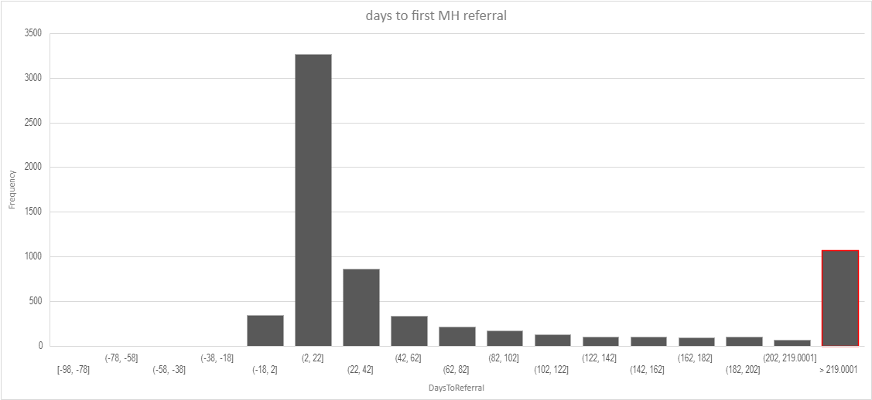
Mental Health in Numbers (2024)
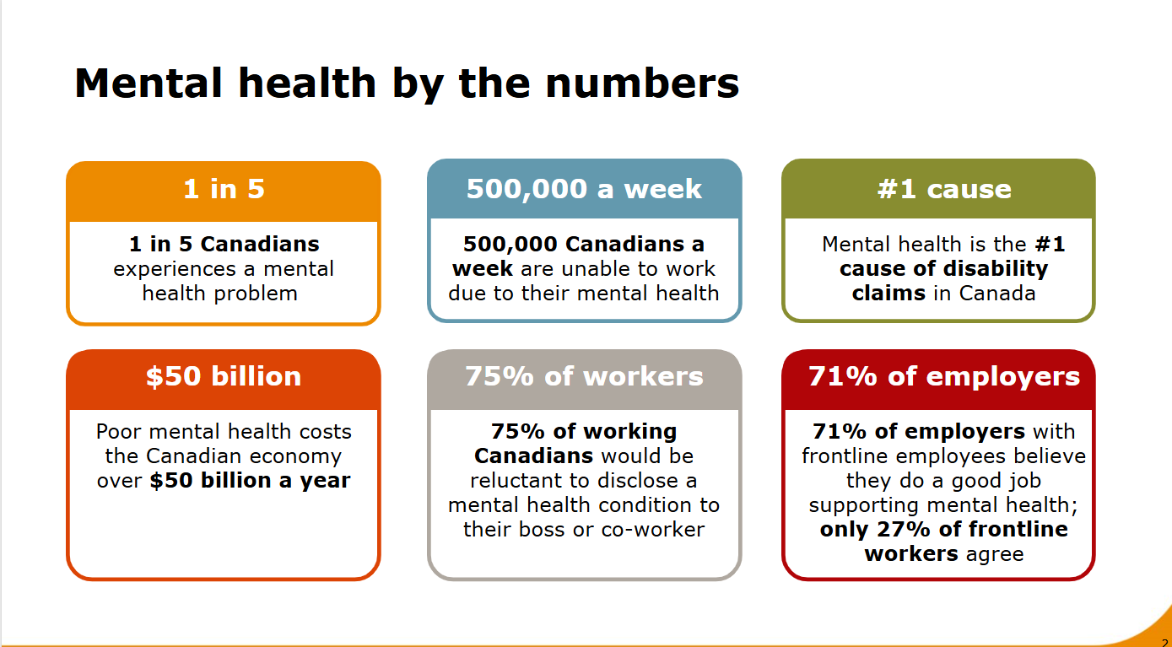

Quote from a worker (optional but powerful)
An anonymized quote like:
“I didn’t know how to talk about what I was feeling. If someone had caught it earlier, maybe I wouldn’t have ended up out of work for a year.”
Shows downstream human impact. Ask a CM if they have a story they can paraphrase.

🗣 Jasper – Senior Claims Manager (SME)
“We deal with hundreds of cases each month, and often by the time chronic pain shows up in the documentation, we’ve already missed the optimal referral window. If Referral Radar can flag these signs earlier—even just a few days—it changes the whole recovery path.”
🗣 Khusboo – Product Owner, Claims Modernization
“The value of Referral Radar lies in its potential to guide decision-making, not replace it. Our goal is always to support the injured worker’s recovery, and this tool strengthens our ability to connect the right cases to the right resources earlier.”
🗣 Michael – Solution Architect, Claims Systems
“From a systems perspective, Referral Radar is lightweight but powerful. It doesn’t disrupt workflows—it plugs into our existing review process and surfaces the insights our case managers wish they had time to find manually.”
🗣 Howard – Director, Healthcare Operations
“If we can reduce even 10% of delayed referrals through early flagging, the long-term cost savings and health outcomes are significant. Tools like Referral Radar help bring clinical thinking upstream, closer to the start of the claim.”
User story aid (from Participatory Budgeting) (Pam)

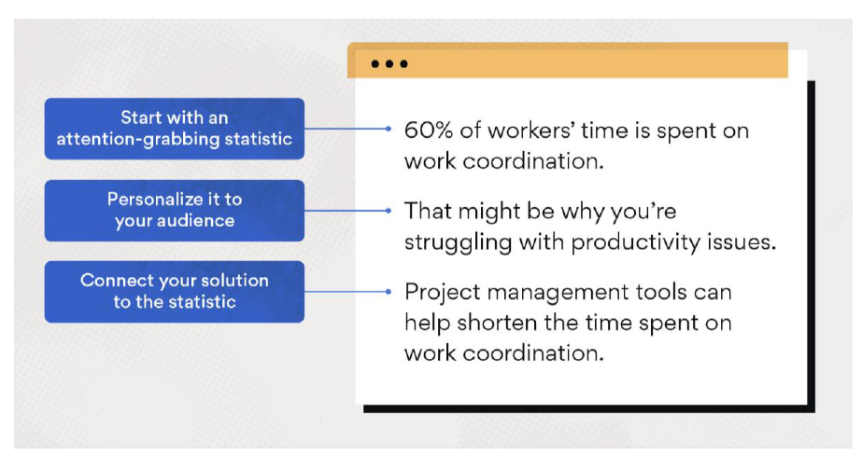

Strategic Alignment

Strategic alignment with WorkSafeBC transformation goals

Referral Radar directly supports WorkSafeBC’s strategic priorities:

WorkSafeBC Priority | How Referral Radar Aligns
Early intervention | Uses AI to detect early mental health risks and recommend timely program referrals
Reducing long-term disability | Empowers case managers to act sooner, improving recovery outcomes and minimizing disability duration
CART Modernization (Claims and Return to Work Transformation) | Integrates seamlessly with CMS workflows to modernize how mental health referrals are triggered and tracked
Operational efficiency | Reduces manual triage and decision-making time through automation and AI-assisted insights
Digital transformation | Leverages Microsoft Azure and OpenAI to build an AI-native solution aligned with WSBC’s cloud-first strategy

Complementary to Existing Systems
CMS: Referral Radar integrates via API (APIM) to analyze CMS claim content and suggest referral actions directly into CMS task flows.
CDW: Can pull structured claim metadata to enrich recommendations.
Healthcare Programs: Recommender engine aligns with existing referral options including Trauma Services, Pain Management, Occupational Therapy, and Psychological Treatment Programs.

Built for scale across other domains
Referral Radar is designed as a modular decision-support tool:
Can be extended to support chronic pain, trauma, addictions, and physical rehab programs
Enables organization-wide AI-driven triage for all complex claim types
Future use case: Return-to-Work program prioritization engine

Visual option for this slide:
4-quadrant visual or table:
- Left: Strategic Pillar
- Right: How Referral Radar supports it
- Bottom: Systems it connects to (CMS, CDW, APIM)
- Top: Future scalability opportunities

- 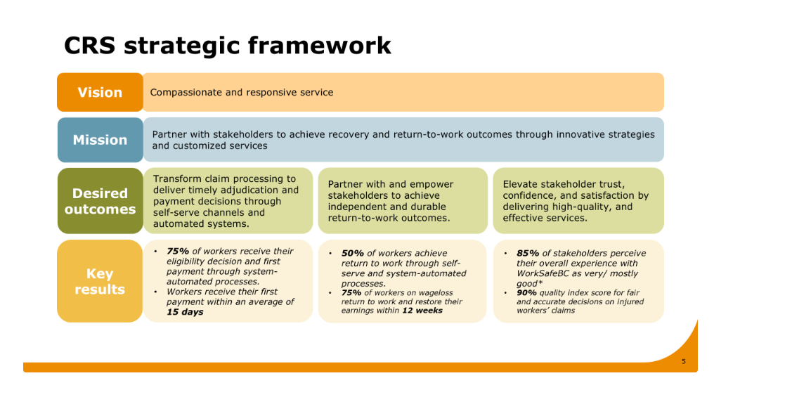

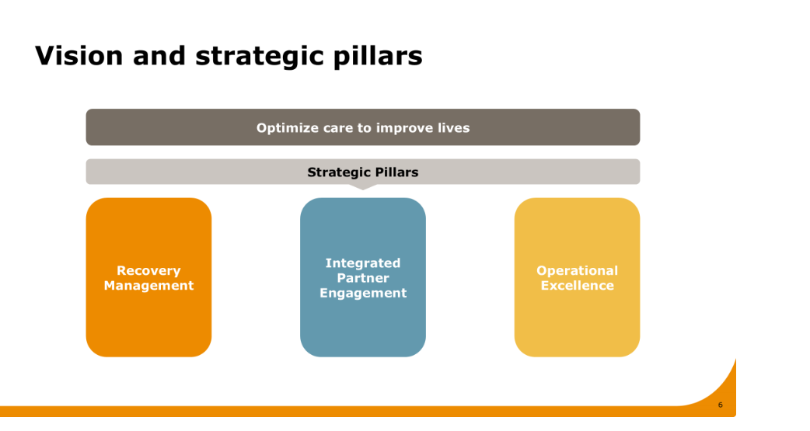

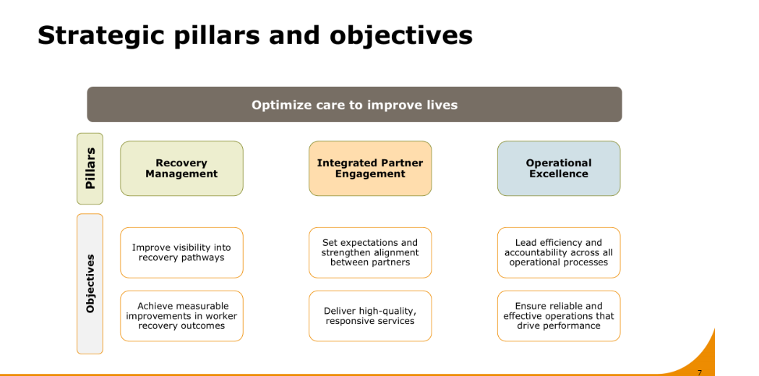

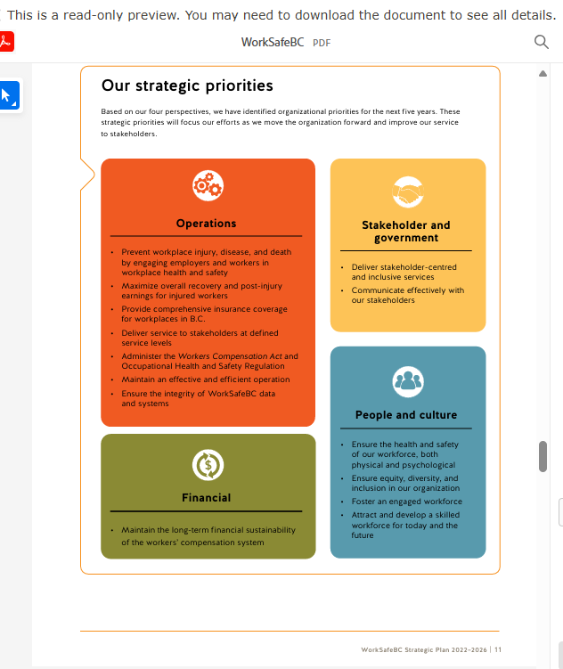

“Referral Radar builds directly on the predictive engine developed by Diego’s team — the same engine that identifies high-risk claims with strong accuracy. What we’ve done is extend that foundation toward productization by integrating decision support, claim summarization, and healthcare program recommendations. Given the known adoption challenges for AI tools, Referral Radar is designed to help bridge the last mile — putting insight in front of the case manager, right when and where they need it.”

“This also gives us a unique opportunity to move from experimentation to something deployable — something real. With the right partnership and support, Referral Radar could be the delivery path for Diego’s prediction engine.”

User Scenarios
Once you have the exact content of the story, covering
Claim Insights
Claim summary
Policy/Procedure rationale
Program soft suggestion
Please share it with tech team.
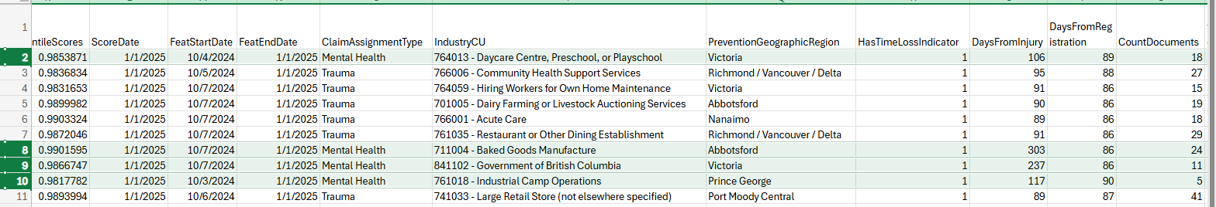

Presentation

This is what Khushboo and I are thinking. We can go over it tomorrow morning once you have thought about it:

10 min presentation breakdown
- Problem statement - 1 min (jasper)
- Product desirability - 1 min (jasper)
- Impact
  - strategic alignment - 1 min 30 sec (abhijit)
  - quantifiable business value - 1 min 30 sec (ricky)
- Product & implementation
  - UI - 1 min (bilal)
  - Agent trace - 1 min (tyler)
  - Architecture & implementation readiness – 1 min (Dmitri)
- Value proposition round up - 1 min (khush)
- Operationalizing/ next steps - 1 min (khush)

